A Church in School Case Study
The Ellis Church - Hemingfield
John, the vicar at St Mary’s Wombwell, and Steph, the Centenary Project worker, run a monthly afterschool service called The Ellis Church.
This regular service usually takes place in the main hall at The Ellis primary school with John, Steph and a few volunteers from St Mary’s. Families from the school attend and occasionally school staff, with an average attendance of 21 people.
3.00 | Team arrive at school to set up
3.15 | Families arrive, snacks are on tables, hot and cold drinks are served by a volunteer.  There is chance to chat and do a craft or two at tables. Instructions are already laid out.
3.45 | Everyone says the opening words together which sets the intention of the session.  Sing a worship action song using a YouTube video e.g. 'Our God is a great big God'.
3.50 | Bible story (usually a video)
3.55 | John gives an all age talk using volunteer children. Often incorporating the crafts, they made.
4.00 | Steph leads the prayer time ending with the Lord’s prayer.
4.05 | Sing an action song e.g. ‘God’s love is big’
4.10 | Final blessing and notices
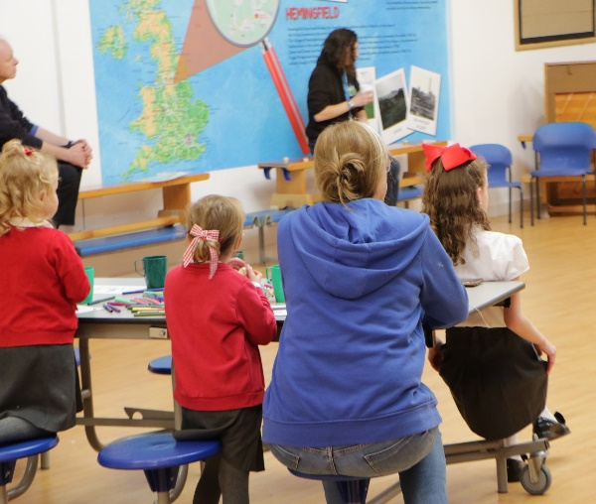
Watching a video
The Ellis Church Structure:


Snacks

Starting up
The school is 2 miles away from the parish church meaning the families who attend the school do not live within walking distance of the church building and are therefore not connected. This makes the school a good strategic location to reach these families.
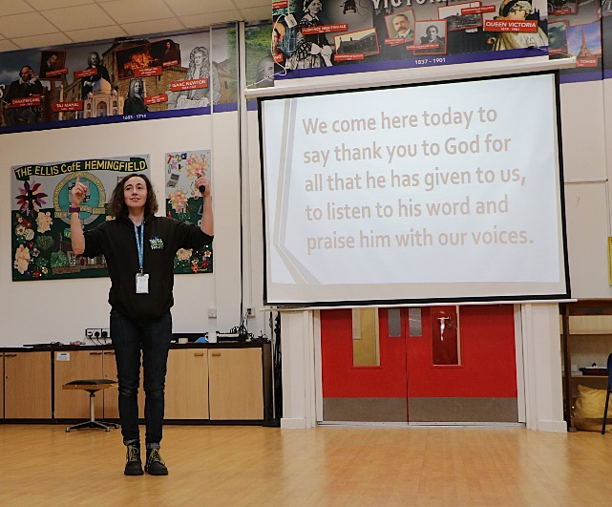
When John arrived in the area, he wanted to work to strengthen the school’s Christian identity. There had been a service in school about 15 years before, but it hadn’t been successful as it was on a Sunday afternoon.
Saying the opening words

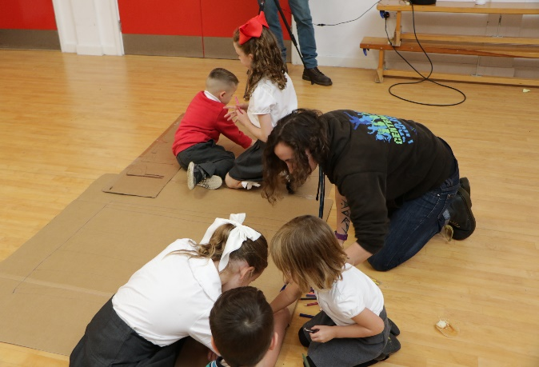
The previous Church in School coordinator began discussions and the team engaged with the previous headteacher, who was very supportive. Plans were in place to begin in 2020, with volunteers and risk assessments ready, but had to be put on hold during the Covid 19 lockdowns. Services eventually began in November 2021, starting slowly and gradually increasing attendance, though numbers still vary with the seasons.
Crafts linking to the story
The majority of attendees are families with young children, and occasionally staff members. While the service feels established, it remains fragile and heavily dependent on John and Steph.

Further connections to the school
Steph and John have a good relationship with the school. Both are governors and John, as RE governor, has seen many good RE lessons being taught.
John leads assemblies weekly and tries to include a Bible text or story to engage with the Christian faith. This was already established before the regular school service. The headteacher suggests themes for the assemblies, like forgiveness, then John matches the theme to a Bible story and tries to link the assemblies to the life of the school.
Steph leads special assemblies and helped build various outdoor learning areas.
Links to the wider church
John believes it is crucial to view the school's work within the broader context of the church's ministry in the area, emphasising that "everything needs to be pointing in the same direction." Many families from the Ellis Church have begun attending the family service at St Mary’s, with others considering the Ellis Church their primary place of worship. Several families have chosen to have their children baptised, but have chosen to have the ceremonies at St Mary’s.
The team distribute flyers to advertise various church events. They also host Messy Easter at St. Mary’s on Good Friday, attracting several families from the school. Currently, they are not conducting school communions but are focusing on increasing Bible knowledge before Confirmation can be considered.
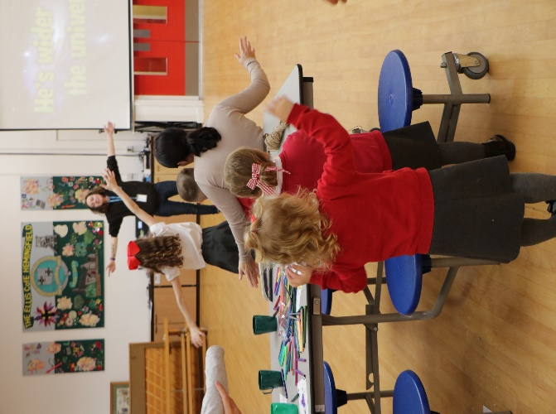
An action song
Planning
John and Steph have regular planning meetings. They follow a theme for a few months (e.g. working through Acts) and have an over-arching long term plan.
Challenges
The team found it disheartening when no one showed up for a session one month, highlighting for them the importance of advertising. Establishing behaviour expectations with the children has sometimes been difficult and recruiting volunteers remains a challenge.

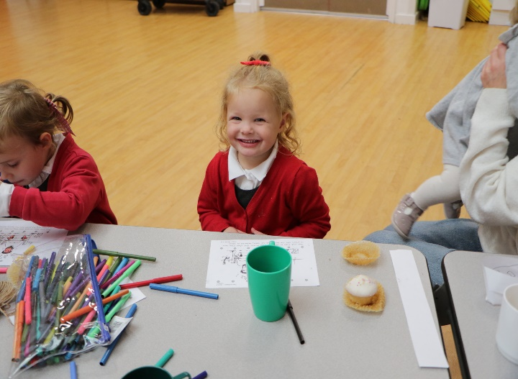
Plans for the future
Craft time
Both John and Steph want to continue running The Ellis Church and embedding it in the life of the school to make it sustainable. Steph would like to link the congregation with another service called ‘camp fire church’ and do some services outdoors as the school is a ‘forest school’ (meaning they have an outdoor forest area).

Advice for anyone nervous about starting a regular service in school
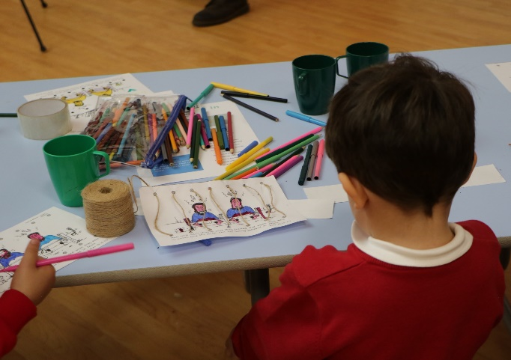
“In schools, generally speaking, you are still welcome as a vicar. Schools still have trust in the dog collar.
Craft time
You have got something important to say.
We assume that everyone is familiar with Bible stories and Christian culture, but they’re not. Teach them the stories of Jesus. At that age, that’s what they need, the foundational stories.

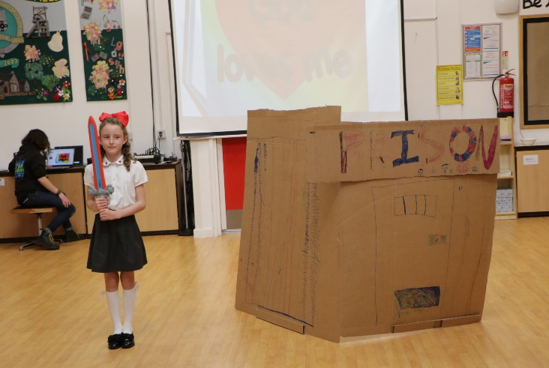
The Bible talk with volunteers
Get the children involved and act out the stories with them.
Build good relationships. Get to know the school, even if you start with a google search and looking at the Ofsted report.”

