Time | Item | Details
3:00 | Set up | Set up room, activities and food
3:30 | Starter activity | Questions or activity printed on each table with pens around  Food/snacks and drinks available
3:40 | Countdown | 5-minute count down on screen
3:45 | Welcome and intro | Welcome new comers and explain structure
3:47 | Song 1 | Song on screen, have a few familiar songs
3:50 | Bible reading | Reading or video
3:53 | Bible talk | All-age Bible talk
4:00 | Activity | Table talk and 1 craft on tables
4:17 | Prayer time | Interactive prayer time
4:22 | News
4:25 | Song 2 | Song on screen, have a few familiar songs
4:28 | Final Prayer and finish | Round up and final prayer  Background music
Example Structures for School-Based Services
Example Session 1 – structured and snappy
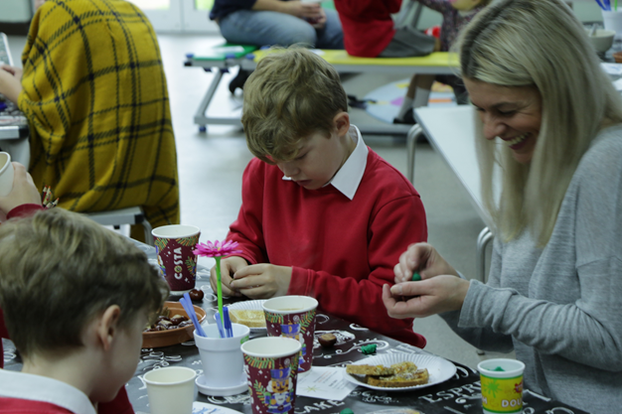

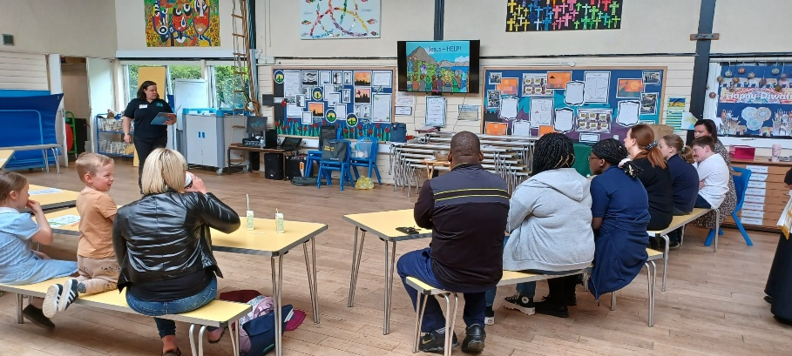

Example Session 2 – informal style
Time | Item | Details
2:45 | Set up | Set up room, activities and food
3:15 | Children and families arrive | Register everyone, snacks on tables, juice given out by volunteers
3:30 | Welcome and Bible story | Tell a Bible story using a video
3:35 | Songs | Songs on the big screen, dance/actions, worship ribbons
3:40 | Crafts and activities | 3 crafts/activities on tables for people to move around
4:10 | Songs | Songs on the big screen, dance/actions, worship ribbons
4:15 | Quick prayer and finish | Quick prayer led from the front
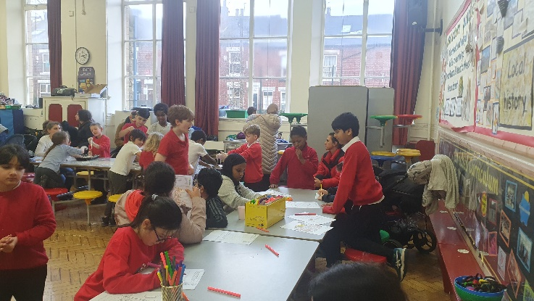
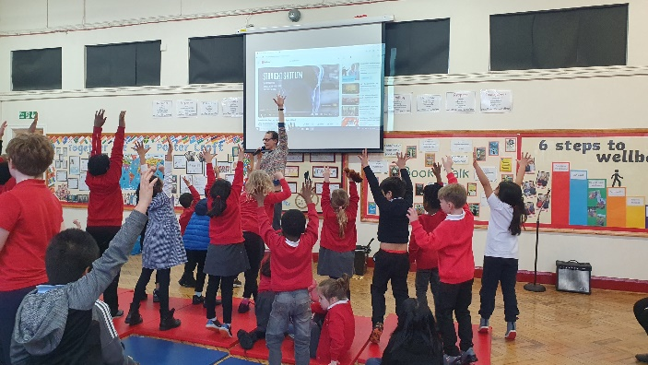

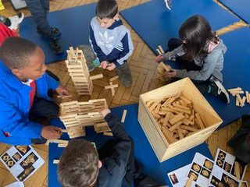
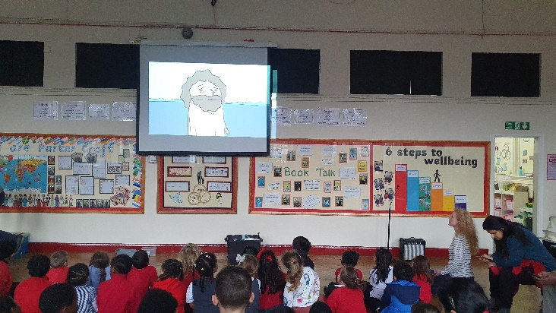

Example Session 3 – eco, outdoor or campfire church
Time | Item | Details
3:15 | Set up | Get equipment, get snacks and drinks ready
3:30 | Children and families arrive | Snacks and hot drinks
3:35 | Welcome and Bible story or talk | Introduce the theme for today and give short talk in a circle outside
3:45 | Song | Acapella song or with guitar
3:50 | Questions | Introduce some questions or things to wonder about
3:47 | Main activity | Gardening, outdoor/eco activity, campfire
4:25 | Prayer | Prayer activity and finish

