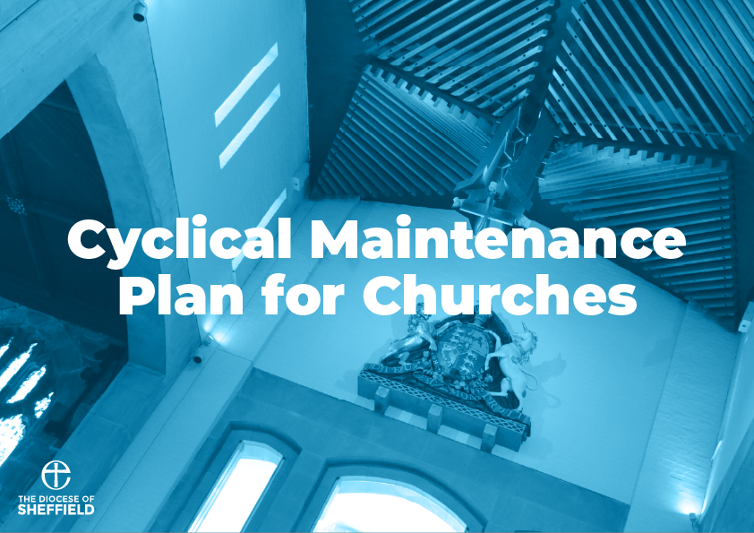

Introduction
The Church of England has set the target of making all churches in England net carbon zero by 2030. Whilst this is an exciting yet challenging target to accomplish, this cannot be achieved without the regular maintenance of our churches.
Maintenance can be split into two categories; annual maintenance which is small scale maintenance that is undertaken on a yearly basis or shorter, such as inspecting roofs and gutters. The other category cyclical maintenance which is larger scale maintenance that is undertaken between longer intervals, such as a Quinquennial report every five years. Whilst most of the annual maintenance checks can be carried out by members of the church or other volunteers (i.e. from a ‘Friends Of’ group) the cyclical maintenance usually has to be carried out by a professional – e.g. your church architect or qualified electrician. In this document we have listed the cyclical maintenance routine checks that you should be undertaking to make sure your church is well maintained. It is important that both annual and cyclical maintenance checks are carried out and implemented for your church building.

How to Use
The cyclical maintenance you will need to carry out will be organised into a table that will include the item of maintenance, what task is required, who will carry it out and how frequently it should be done. A budget section and a list of years will also be included for you to fill out yourself, simply fill in how much it will cost for each maintenance project and tick the years they were completed. This is so you can keep track of what has been done and when, so you know exactly when to carry out the next batch of cyclical maintenance. The headings for the table are shown in an example below. The resource provided will cover the cyclical maintenance cycle until 2051, so keep this document safe!
Item | Task | Who? | How Often? | Budget (£) | 2022 | 2023 | 2024 | 2025 | 2026 | 2027 | 2028 | 2029 | 2030 | 2031

It is important you keep track of any maintenance has been carried out so that you don’t miss out any areas that may have been forgotten about, or carry out checks again when they don’t need to be. It also helps the Church Buildings team in the diocese understand where we are with our maintenance goals, and therefore if we are on track to deliver targets on our path to Net Zero emissions.
Finally, please ensure you act on any issues that you find when making your maintenance checks. Finding an issue is important, but so is fixing it!

Cyclical Maintenance Table
Item | Task | Who? | How Often? | Budget (£) | 2022 | 2023 | 2024 | 2025 | 2026 | 2027 | 2028 | 2029 | 2030 | 2031
External drains and soakaways | Check for any blockages or silting up of filters and main drain pipes | Contractor | Every 2 years
Fixed Electrical Installations | Inspect wiring and fixed electrical installations in accordance with current regulations. | NICEIC or ECA Registered Electrical Contractor | Every 4 Years
Quinquennial Inspection | Carry out Quinquennial Inspection. | Architect/ Surveyor | Every 5 Years
Tower and Spire | Close quarters inspection of tower and spire (if applicable) and other generally inaccessible high-level areas, remove loose masonry that could fall. | Steeplejack | Every 5 Years in summer months
Item | Task | Who? | How Often? | Budget (£) | 2022 | 2023 | 2024 | 2025 | 2026 | 2027 | 2028 | 2029 | 2030 | 2031
Lightning conductor system and flag pole | Check the system is intact and in good order. | Qualified contractor | Every 5 years
Exterior Woodwork | Rub down and repaint. | Contractor | Every 7 Years in summer months
Cast Iron Rainwater Goods | Rub down and repaint. | Contractor | Every 7 Years in summer months
Metal railings | Rub down and repaint. | Contractor | Every 7 Years in summer months

