How to Register Your Church to Claim Gift Aid

Disclaimer
Please note that this guide on registering for Gift Aid is not exhaustive The guide was sourced from the HMRC website page Get recognition from HMRC for your charity - GOV.UK (www.gov.uk).
I have provided links to specific areas on the HMRC website where relevant.
The instruction guide is current as of 14th April 2023. The guide will be checked regularly to ensure it is up-to-date and aligned with HMRC policy.
If you have any queries, please contact Janet Daye at the Diocese of Sheffield. Contact details are at the bottom of this page.
The Generosity and Finance Team hope you find this resource helpful.

Janet Daye
Treasurer and Church Operations Project Support Officer | The Diocese of Sheffield
Email: janet.daye@sheffield.anglican.org.uk
Tel: 07731998063
Web: www.sheffield.anglican.org | Post: 95-99 Effingham Street, Rotherham, S65 1BL

Follow us on Twitter @DioceseofSheff
Find us at https://www.facebook.com/dioceseofsheffield

The Sheffield Diocesan Board of Finance is a company limited by guarantee and registered in England (No 196087) at Diocesan Church House, 95-99 Effingham Street, Rotherham S65 1BL. Registered Charity No. 245861

How to Register your Church to Claim Gift Aid

Contents
Please follow in content order
1. Information required for registration 3
2. Check your eligibility to claim Gift Aid 4
3. Registering with the Government Gateway to Claim Online 5
4. Registering to Claim Online: Completing the process 7

Information required for registration
You will need to be able to provide or confirm the following information:
- bank account details and financial accounts

- officials’ details, including dates of birth and National Insurance numbers.
- You will need up to 2 authorised officials. Only these named persons will be able to claim gift aid on behalf of the church

- registration number if you’ve registered your charity with a regulator i.e. the charity commission.
IMPORTANT - Do not use the Diocese of Sheffield charity number. The ‘registration number’ is a unique identifier the Charity Commission gives you on registering your church with them.
- You don’t need to register your church with the charity commission if your annual gross income is less than £100,000

- charitable objectives (sometimes called purposes)
- A church’s charitable purpose contributes to religion. Therefore, a church has charitable objectives

- governing document (sometimes called a rulebook) - this explains how your charity is run
- The church’s constitution document is your governing document. The document would have been written when the church was first set up and may have been amended in places over the years
- If you can’t find your governing document you can download proof of your charity status on the A Church Near You website: https://www.achurchnearyou.com/ . Go to your church page, select More Information on the left-hand pane, then select download certificate. HMRC will accept the certificate as proof of your charitable status.

- Government Gateway user ID and password - you can create an account if you don’t already have one during registration.
- If your church has PAYE, then you will already have a Government Gateway user ID and password for your church

Check your eligibility to claim Gift Aid
Follow the link:
- The link will take you to an HMRC page to allow you to register online
Get recognition from HMRC for your charity - GOV.UK (www.gov.uk)
On this home page, there are four links to pages to check your charity’s eligibility to claim Gift Aid. Ensure you have the documentation or information to hand to enable your charity to register with HMRC.
Select the green Start Now button.
The final page will confirm that your church can claim gift aid, and the registration process will follow.
1 - Check if you can register the charity
- Ignore this if your annual gross income is less than £100,000.
Select ‘Continue’.
2 - Is the charity for charitable purposes only?
Select ‘Yes’
Select ‘Continue’.
3 - Does the charity have a UK bank, building society or credit union account
Select ‘Yes’
Select ‘Continue’.
4 - Is the charity based in the UK?
Select ‘Yes’
Select ‘Continue’.
5 - The charity is eligible for this service
Select ‘Continue’.

Registering with the Government Gateway to Claim Online
When you have completed entering the information to check your eligibility to claim gift aid, in points 1 to 5 above, the system will ask you to enter your Government Gateway user ID and password.
- If you do not have a Government Gateway user ID and password, select ‘Create sign-in details’ underneath the title ‘New users of the Government Gateway’.
- If you already have Government Gateway user ID and password enter it on this page
6 - If selected ‘Create sign-in details’
Enter your email address and then enter the temporary code emailed to you.
- Provide your full name and create a password and recovery code. Your password must:
  - be between eight and twelve characters (letters and numbers)
  - contain at least one digit (0-9) and at least one letter (a-z)
  - The system will generate a 12-digit Government Gateway User ID. HMRC will email the User ID to you. Print the page on the screen to have the ID for future reference. Keep this safe; you will need the User ID and password every time you log in to use HMRC online services. Then click the 'Next' button.
7 – Choose the type of account you need
Select ‘Organisation’
Select ‘Continue’
The system will direct you to a 'Business tax summary' page.
8 – On the Business tax summary page click on ‘add a tax, duty or scheme’
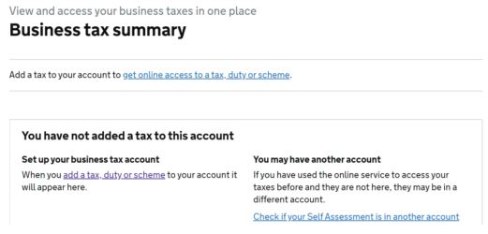

9 – In ‘What do you want to add?’ select ‘Other taxes or schemes’ then ‘Continue’
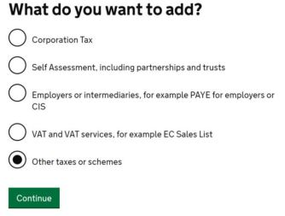

10 – In ‘Select a category, select 'Charities – for Gift Aid repayment claims
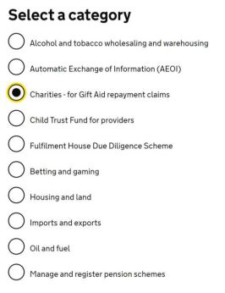

11- Enter your charity details
You will need to enter:
- Your HMRC Charities Reference Number (often beginning with an X),
- and the postcode of the address registered with HMRC (usually your authorised official), and either the last four digits of the bank account number that HMRC will use to pay your Gift Aid claims, or
- if you registered with HMRC after 6th April 2013, your customer account number.
Then click the ‘Request Access’ button.
You now need to wait for an Activation code to arrive in the post from the Government Gateway. The letter you receive from HMRC will have a tear-off cover over a part of the letter, revealing a twelve-digit activation code.

Registering to Claim Online: Completing the process
When you receive the letter from the Government Gateway, you will need to complete the registration process by following the instructions in the letter:
Log in to HMRC Online Services using your Government Gateway user ID and password, and you’ll see ‘Charities’ listed as one of the ‘services you can use’. Select ‘Charities’. You’ll then need to:
- Select ‘activate service’.
- Enter your Charities Online activation code.
- Select ‘activate’.

