How to claim Gift Aid

Disclaimer
Please note that this guide, ‘How to - claim Gift Aid’, is not exhaustive. The guide was sourced from HMRC and Parish Resources websites.
HMRC provides detailed guidance notes on how Gift Aid and on how the Gift Aid Small Donations Scheme operates. Please refer to the links:
Chapter 3: Gift Aid - GOV.UK (www.gov.uk)
Chapter 8: The Gift Aid Small Donations Scheme from 6 April 2017 - GOV.UK (www.gov.uk)

The guide, ‘How to - claim Gift Aid’ is current as of the 28th of March, 2023. The guide will be checked regularly to ensure it is up-to-date and aligned with HMRC policy.

I have provided links to specific areas on the HMRC and Parish Resource websites where relevant.
I have linked the guide to sample donor records, schedule templates, and examples of completed templates for your use and reference.
If you have any queries, please contact Janet Daye at the Diocese of Sheffield. Contact details are at the bottom of this page.
The Generosity and Finance Team hope you find this resource helpful.

Janet Daye
Treasurer and Church Operations Project Support Officer | The Diocese of Sheffield
Email: janet.daye@sheffield.anglican.org.uk
Tel: 07731998063
Web: www.sheffield.anglican.org | Post: 95-99 Effingham Street, Rotherham, S65 1BL

Follow us on Twitter @DioceseofSheff
Find us at https://www.facebook.com/dioceseofsheffield
The Sheffield Diocesan Board of Finance is a company limited by guarantee and registered in England (No 196087) at Diocesan Church House, 95-99 Effingham Street, Rotherham S65 1BL. Registered Charity No. 245861
Contents
What is Gift Aid? 3
Gift Aid cannot be claimed on: 3
To make a Gift Aid claim you must 3
Register with HMRC 3
Have a Gift Aid Declaration for eligible donations 3
A Gift Aid Declaration must include 4
Changes to a donor’s circumstances 5
Sponsored Events and Gift Aid Declaration 5
Links to Gift Aid Declaration templates 6
Consider topping up your Gift Aid claim under the Gift Aid Small Donations Scheme (GASDS) 7
Donations are acceptable under GASDS if: 7
To claim top-up payments for donations, you must: 7
You cannot claim GASDS for: 7
The maximum amount of small donations top-up payments you can make in a year 8
If you’ve merged with another parish by union after 6 April 2017 8
If you’ve merged with another parish by union before 6 April 2017 8
Follow special rules for claiming Gift Aid 8
Keep a Donation Record for all Gift Aid claims 9
For donations that have a valid gift aid declaration 9
Retaining donation records 9
For cash collections eligible under GASDS 10
For contactless donations 10
How to claim Gift Aid 11
Completion of the HMRC’s schedules to make an online claim 11
Claiming GASDS on donations received from other church buildings in your parish 13
Submit your Gift Aid claim 15
Frequency of gift aid claims 18
When you must claim 18
Keeping records of Gift Aid and GASDS claims 19
When you’ll get paid 19
For help on your claim 19
Advise on Church Collections 19
Tax relief for higher earners 19

What is Gift Aid?
You can claim back from HMRC 25p every time an individual donates £1. This is called Gift Aid.
To claim Gift Aid, donors must complete a Gift Aid Declaration.

Gift Aid cannot be claimed on:
- Payroll giving
- Donations from Limited Companies
- Goods or services
- Shares
- Vouchers or charity cards
- Membership fees

To make a Gift Aid claim you must

Register with HMRC
A guide is available on how to register for Gift Aid. Please refer to the guide ‘How to Register with HMRC to claim Gift Aid’.

Have a Gift Aid Declaration for eligible donations
When a donor completes a gift aid declaration, it gives the church permission to claim Gift Aid on donations given by:
- Planned Giving received by standing order, cheque
- One-off Donations received by cheque, online bank transfers
- Cash or cheques, given through the Envelope Scheme
Gift Aid can only be claimed on cash donations if the person donating puts the cash in an envelope with their name on it. If the donor hasn’t completed a declaration in the past s/he will need to insert a completed Gift Aid Declaration
- Website giving
Website donations legally require an online Gift Aid Declaration. Sometimes, a donor can complete a Gift Aid declaration during the website donation process. Otherwise, paper versions and a tick box alongside contact details are required. An available gift aid declaration process is dependent on whether the website’s 3rd party provider, who collects payments on behalf of the website, has this facility.
3rd party providers often have a processing fee applied to the donation paid. If a processing fee is applied, the charity receives a reduction in the total donation paid. The gross donation is eligible for Gift Aid regardless of any processing fees that the charity may incur.
- Contactless giving
For contactless donations greater than £30, ensure your contactless device has built-in gift aid declaration functionality so the donor can complete a declaration.
  - Important note for claiming Gift Aid on donations made using digital platforms
Digital platforms usually use a 3rd party provider. The provider collects and processes donations received via the device. Donations may incur a processing fee. If a processing fee is applied, the charity will receive a reduced total donation. The gross donation is eligible for Gift Aid regardless of any processing fees the charity may incur.
  - Payments not eligible for the Gift Aid Scheme
- payment of school fees for a specific person
- payment to purchase books, jumble sale items, food
- payment for admission to events (jumble sales, concerts)
- payment for raffle or lottery tickets (including 100 clubs) — the payment to purchase a raffle ticket from a charity is not a gift but a payment for the right to enter the raffle — it does not matter that the chance or expectation of winning a prize is small or that the prize is of little value.

A Gift Aid Declaration must include
There is no set design for a declaration form or a verbal declaration, but it must include the following:
- the name of your charity
- the donor’s full name
- the donor’s home address
- whether the Declaration covers past, present or future donations or just a single donation
- a statement that the donor wants Gift Aid to apply (this could be a tick box on a written or online declaration)
- the donor confirms that s/he is a UK Income or Capital Gains taxpayer. The donor understands that if s/he pays less Income Tax / or Capital Gains tax in the current tax year than the amount of Gift Aid claimed on all of their donations it is their responsibility to pay any difference.
A declaration by a donor can be made in writing, verbally or online. Whichever format you use, donors must provide the required information for your Gift Aid claim to be valid.
A verbal declaration must be recorded or confirmed in writing.
You must keep all Gift Aid declarations. A Gift Aid declaration must be available for any claim made on a donor's donation.

Changes to a donor’s circumstances
The person who completed the Declaration is responsible for informing you of any changes to their name, address, or tax status in writing. A letter, email or text message is acceptable. The church must keep a copy of the donor's instruction with their gift aid declaration. Any instruction to a change in donor's details must be adhered to, from the date of notification when making future gift aid claims.

Sponsored Events and Gift Aid Declaration
If you’re organising a sponsored event, like a marathon, your sponsorship forms can include a Gift Aid declaration. The Declaration must state that the donor needs to pay the same amount or more of UK Income Tax and/or Capital Gains Tax in that tax year. Also, you will need to include a tick box on the sponsorship form so that the donor agrees to Gift Aid being claimed.
The forms must also include the:
- amount of donations collected
- date that pledged donations were collected
- date, when the sums collected were handed over to you.

  - Rules around sponsorship of a fundraising event
- All sponsors must complete a Gift Aid declaration
- Flights, accommodation and other support costs are not gift-aidable if the event is to be held abroad
- Deposits or registration fees are not eligible
- Suppose there is a connection between the event participant and a sponsor. In that case, the sponsor's donation is only gift-aidable if the participant pays the total support costs to participate in the event.

Links to Gift Aid Declaration templates
- for multiple donations:
https://assets.publishing.service.gov.uk/government/uploads/system/uploads/attachment_data/file/468016/Charity_GAD_Multiple_Donations.pdf
- for one-off declarations:
https://assets.publishing.service.gov.uk/government/uploads/system/uploads/attachment_data/file/467898/Charity_GAD_Single_Donation.pdf
- for sponsored events:
https://assets.publishing.service.gov.uk/government/uploads/system/uploads/attachment_data/file/473639/Sponsorship_and_Gift_Aid_declaration_form_-_Nov_2015.pdf

Consider topping up your Gift Aid claim under the Gift Aid Small Donations Scheme (GASDS)
Before you make a claim for Gift Aid it is worth considering claiming a top-up payment of 25% on cash or contactless donations of £30 or less under the Gift Aid Small Donations Scheme at the same time.
You do not need to know the identity of the donors or collect Gift Aid declarations.
From 6 April 2016, you can claim up to £2,000 in a tax year or £1,250 for earlier years.
For charities, the maximum donations limit is £8,000 per tax year. This limit applies to eligible small donations collected anywhere in the UK.
Charities can choose whether to claim top-up payments on one of either:
- up to £8,000 on donations collected anywhere in the UK
- up to £8,000 for each community building, under the new community buildings rules.
You must make a claim under GASDS within 2 years of the end of the tax year ie 05/04/20XX

Donations are acceptable under GASDS if:
- Received by contactless terminal by card, phone or another device
- The cash is in any currency
- The donation is made in the UK
- Donations are deposited in a UK bank account
- There are no benefit links to the donor on receipt of the donation
- Cash donations are for either food or drink.

To claim top-up payments for donations, you must:
- have claimed Gift Aid in the same tax year as you want to claim a top-up payment
- not have incurred a penalty on a Gift Aid or GASDS claim in the current or previous tax year.

You cannot claim GASDS for:
- donations that come with a valid Gift Aid declaration
- membership fees
- a £30 portion of a larger gift.

The maximum amount of small donations top-up payments you can make in a year
If your charity has a community building (for example, a village hall or religious building), you might be able to claim more on donations collected either:
- in your community building
- in the same council area as your community building, if you collected the donations on or after 6 April 2017.
For somewhere to count as your community building, you need to have hosted at least 6 charity events there. The events must have all been attended by at least 10 people.

If you’ve merged with another parish by union after 6 April 2017
You can start claiming under GASDS straight away as long as you’re also claiming Gift Aid in the same tax year.

If you’ve merged with another parish by union before 6 April 2017
You will need to follow HMRC rules. Please refer to: Claim top-up payments for the Gift Aid Small Donations Scheme - GOV.UK (www.gov.uk)

Follow special rules for claiming Gift Aid
There are special rules for:
- funds from sponsored challenges for example, overseas treks or marathons
- charity membership fees
- church collections
- selling goods on behalf of individuals, for example, through a charity shop
- charity events or to view charity property
- charity auctions
- volunteer expenses donated back to your charity or CASC
- funds raised through charities involved in running schools.

Keep a Donation Record for all Gift Aid claims

For donations that have a valid gift aid declaration
A spreadsheet is most often used to record all regular and one-off donations given by donors. A separate spreadsheet helps record this information for each claim period. This information will provide the supporting evidence required for a church to make a gift aid claim. Record the following information:
- Donor name
- regular monthly payment amounts and one-off payment amounts per month.
Here is an example of a partially completed donation record prepared using a spreadsheet:
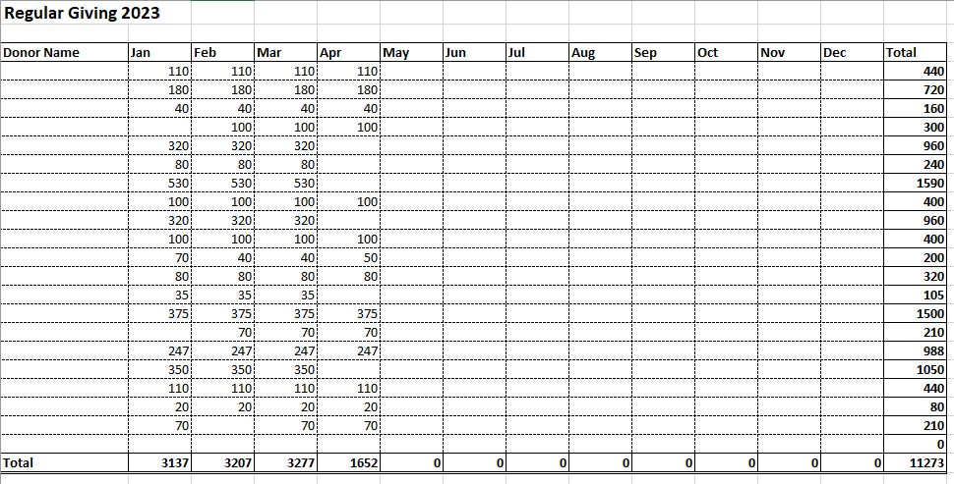
The example automatically sums the donations recorded for each donor in the end column. When you claim Gift Aid use the total figure donated by each person for each claim period.
Ensure you have a Gift Aid Declaration for every donor when you make a claim. If donors do not have a declaration, you must exclude their donations from the claim.
A Donation Record template is available here. Customise the spreadsheet for your church use.
You must file the donation record with the claim.

Retaining donation records
You must keep a donation record for 6 years from the end of the financial year in which the donations were collected. For example, for donations given in 2019 and a gift aid claim made in 2020, a donations record must be retained until the 31st of December 2025.

For cash collections eligible under GASDS
You need to keep records of small donations as evidence of your claim. Two people should check and count the cash collected.
You should record:
- how much money was collected. The record should show totals for each denomination of coin and note
- the date the money was collected
- that no individual donation was greater than £30
- name and signature of the people who counted the cash.

For collections in community buildings you will also need to record:
- the address of the place you collected the donations (including postcode)
- the type of event
- the number of events you held
- an estimate of how many people were at the event
- when you collected the donations.

For contactless donations
If you've collected contactless donations, you'll need to keep the records produced by the contactless terminal. The records will report how much money was transferred into your bank account on a particular date. For each deposit made into your bank account, the record will show the names of the donors, the gross donation, the processing fee, and the net amount deposited per person.
Add gift aid declarations to your donation station if your contactless device allows it. If completed by a donor, this facility will enable gift aid to be claimed on individual donations greater than £30.

How to claim Gift Aid
You can claim Gift Aid using Charities Online with the following:
- eligible software, like a database
- a spreadsheet of your donations.
For claims of over 1,000 donations you must use software.
To apply by post use form ChR1, which you can get from the charities helpline.
HMRC has a list of eligible software and service suppliers listed on their website. All the suppliers have provided evidence that they have developed software that can interact with the HMRC Charities Online service. You can find the list here:
https://www.gov.uk/government/publications/charities-online-commercial-software-suppliers/charities-online-commercial-software-suppliers
The list includes:
- accounting software that enables you to claim Gift Aid directly: eg ExpensePlus and Liberty Accounts
- donations management software that allows you to claim Gift Aid directly: eg Data Developments – MyGiving.Online.

Completion of the HMRC’s schedules to make an online claim
To submit an HMRC's schedule spreadsheet, save the document in Open Document format (ODF). You must have one of the software programs below installed on your computer for schedules to be saved as an ODF document:
• Microsoft Excel - Microsoft Office 2010 for Microsoft Windows
• LibreOffice 3.5 for Microsoft Windows, Apple Mac OS and Linux
I have attached a Microsoft Office 2010 ODF schedule template for your use.

The Libre Office software and its associated schedule can be accessed from the link below.
Schedule spreadsheet to claim back tax on Gift Aid donations - GOV.UK (www.gov.uk)

  - Instructions on how to complete the HMRC schedule for Microsoft Office
To claim Gift Aid when using Microsoft Windows, you must use and complete the relevant HMRC Gift Aid schedule spreadsheet available on their website. The link is gift_aid_schedule_version_3.ods (live.com). The spreadsheet must be saved as an ODS file. Below is a copy of the schedule:
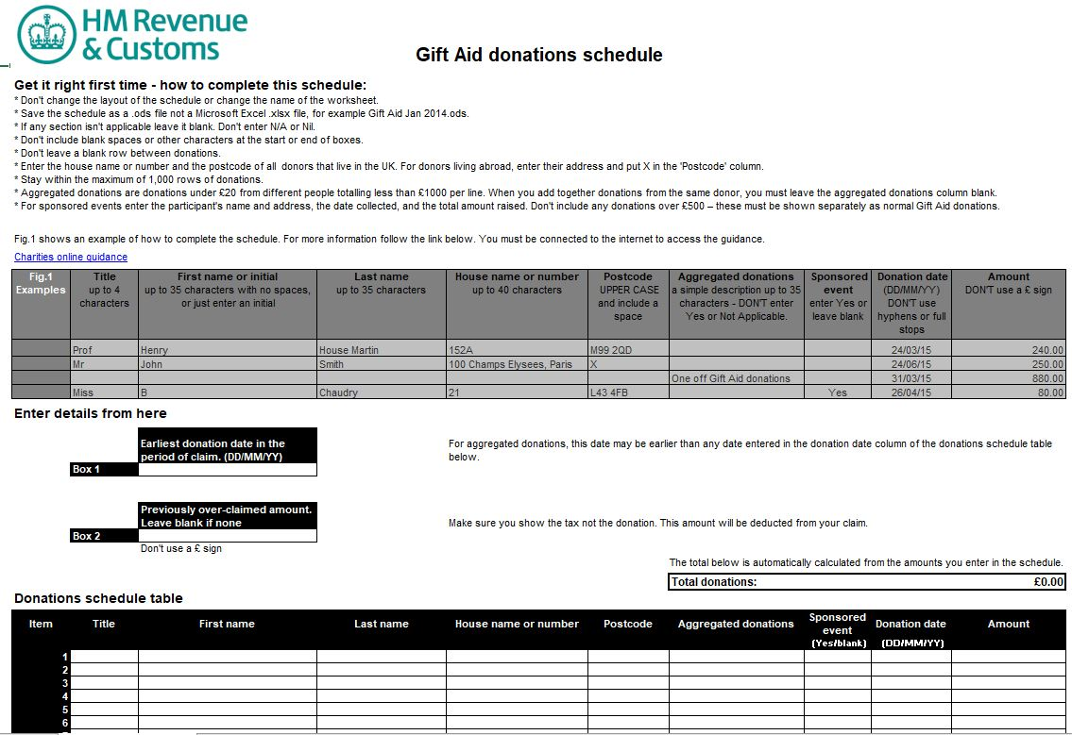
At the top of the ODS schedule template are instructions for completing the spreadsheet. Underneath the schedule instructions, there is a link to Charities Online if you require further guidance.
After the schedule instructions, there are examples on how to complete the schedule.
Underneath the example section, there are two boxes on the left-hand side. You must enter the earliest donation date for your claim in Box 1, and any overclaimed tax amounts from previous claims in Box 2.
Below that, you need to enter information about the donors:
- enter their Title, Initial or First Name and Last name
- enter house name or number and the postcode
- for the donor, enter the date of the donation, or the last donation date if the donor has given multiple donations within the period you are claiming for
- the total amount the donor has given.
You can enter aggregated donations of £20 or less, up to a total of £1,000 per row. This can be helpful for one-off Gift Aid envelopes, or for one-off donations where the donor has completed a gift aid declaration.
To claim aggregated donations, leave the donor details blank, and enter a simple description in the Aggregated Donations box.
The spreadsheet will calculate the total donation amount and you can view the total at the top of the schedule.
Save and close the spreadsheet as an ODS file.

Claiming GASDS on donations received from other church buildings in your parish
Complete a community building schedule if donations were given at the church hall or donations were given at another church in your parish. The schedule you must complete for community buildings if you are a Microsoft Windows user can be found here: community_buildings_excel.ods (live.com).
Below is a copy of the schedule:
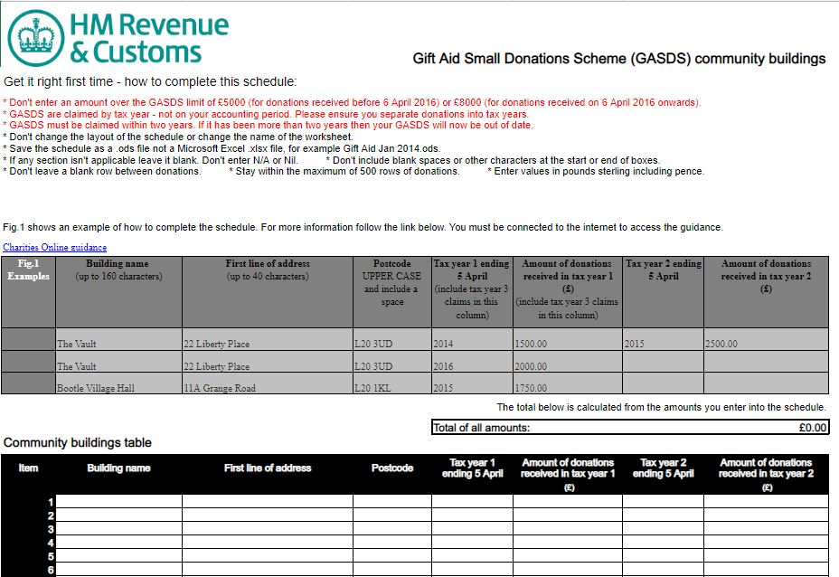
At the top of the ODS schedule template are instructions for completing the spreadsheet. Underneath the schedule instructions, there is a link to Charities Online if you require further guidance.
After the schedule instructions, there are examples on how to complete the schedule.

You’ll need to enter in the schedule spreadsheet the:
- community building name (maximum 160 characters)
- first line of the building address (maximum 40 characters)
- postcode
If you do not know the postcode, you can find it out on the Royal Mail postcode finder website. If the building doesn't have a postcode, enter the postcode of its nearest building.
You’ll also need to enter the:
- end of the tax year for which you’re claiming under GASDS
- the amount of all small donations of £30 or less collected in each community building.

Submit your Gift Aid claim
- Log into the Government Gateway
Follow the link: Claim Gift Aid online - GOV.UK (www.gov.uk)
- Click the Green 'Start Now' button to direct you to the Government Gateway.
- The system will automatically generate an access code sent to your mobile.
- Enter your ID, password, and access code and click the green ‘Sign In’ button.

Access the services available:
- Select ‘View Account’ – highlighted in the red box in the screenshot below

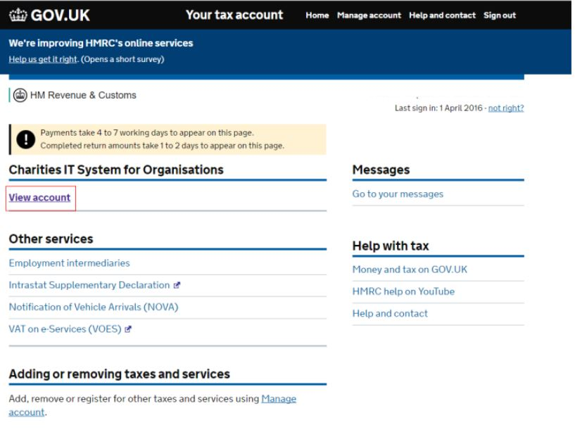

- Click on ‘Make a charity repayment claim’.
The window that appears will ask you questions about your claim.

- Answer questions about your claim
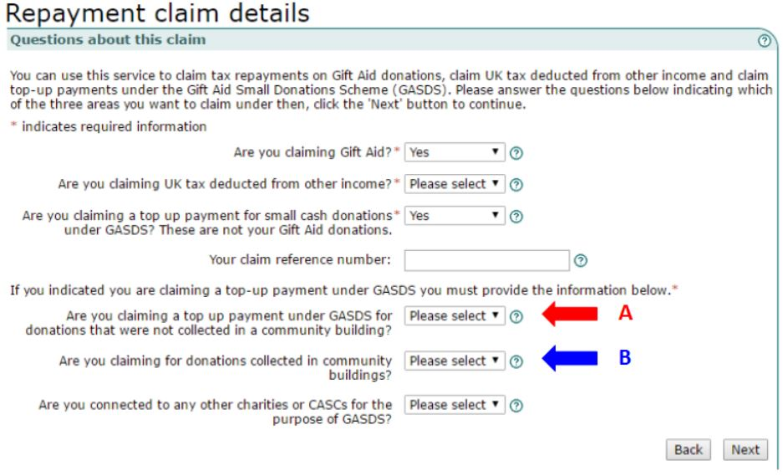For the questions shown in the window, select:
- Are you claiming gift aid? - Yes
- Are you claiming UK tax deducted from other income? – No.
- Are you claiming a top-up payment for small cash donations under GASDS? These are not your gift aid donations. – Select Yes if claiming for GASDS; otherwise, select No.
- If you have selected Yes to the question above and you have only one church building, you need to answer Yes for the question marked with the red A arrow; otherwise, answer No.
- If you raised collected cash in multiple buildings, select Yes for the question marked with the blue B arrow.
- For the last question, ‘Are you connected to any other charities or CASCS for the purpose of GASDS’ select the question mark icon at the end of the drop-down box. The icon provides help on which answer to choose. Usually, the answer is No.
- In the box labelled 'Your claim reference number', enter a name that identifies the claim and claim period.
  - Select the ‘Next’ button

Another window will appear that asks you for details about your church.
- Enter details about your church.
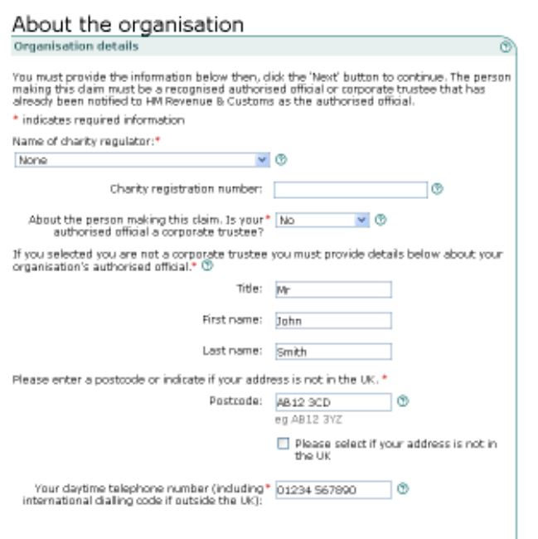

Provide the following information in the window:
- If you are not registered with the Charity Commission - from the drop-down menu under the title ‘Name of Charity Regulator’ select ‘None’ then select ‘Excepted’.
- Leave the field for Charity registration number blank.
- Select ‘No’ for the question ‘Is your authorised official a corporate trustee?’
- Provide details of your authorised official in the next set of fields. The official is the person authorised to claim on your behalf. You would have notified HMRC of your chosen authoriser when you registered for gift aid or if you changed the authorised user.

- Upload your completed schedules
The system will now ask you to upload your completed schedules in this order:
- Gift Aid Schedule
- And/or Community Buildings schedule.
The system will automatically check the schedules for any formatting errors. The system will show your uploaded schedule on the screen if everything is okay. If there is an error in the schedule, the system will tell you the error. It could be a missing house number, name, or incorrect entry formatting. At this point, you will need to correct the schedule and re-upload it.
When you are happy that the correct schedules are uploaded, the system will tell you if the schedule is successfully attached.
After successfully attaching your schedules, you will be asked to enter the GASDS total if you selected ‘Yes’ to the question 'Are you claiming a top-up payment under GASDS for donations not collected in a community building'.
- Submit your claim
To submit, you must tick the Declaration screen's check box. Then, as a security check, you must re-enter your user ID, password and the access code sent to your mobile. When you have entered this information, select the ‘Submit’ button.
On successful submission, HMRC will present you with a receipt on the screen stating that your claim was successful. The receipt will show a reference number. Please print this screen or note the reference number for future reference.

Frequency of gift aid claims
You can make as many gift aid claims as you want throughout the financial year. It is best to claim regularly to help with cash flow. If a church receives large monthly donations, it is also advisable to claim periodically, either monthly or quarterly, throughout the financial year.

When you must claim
You need to claim Gift Aid on a donation within 4 years of the end of the church financial year (the 31st of December) you received it.
You must claim on cash donations under the Gift Aid Small Donations Scheme within 2 years of the end of the tax financial year that you received the donations.

Keeping records of Gift Aid and GASDS claims
You need to keep records of any Gift Aid claims you have made for 6 years of the end of the church financial year (the 31st of December) you received it.
Claims on cash donations under the Gift Aid Small Donations Scheme must be kept for 4 years within the tax financial year that you received the donations.

When you’ll get paid
You’ll get a Gift Aid payment by BACS within:
- 4 weeks if you claimed online
- 5 weeks if you claimed by post using form ChR1

For help on your claim
Contact the charity's helpline if your repayment needs to be corrected or if you submitted an incorrect claim.

Advise on Church Collections
You cannot claim Gift Aid on donations collected in your church and given directly to another charity. That is, the money collected does not go through the church's bank account.
If a church chooses to set up a fund to raise money for a charity, then the money collected forms part of the church's income. In this case, the church can claim the Gift Aid due.

Tax relief for higher earners
It is advisable to state on any publicity material or newsletters that higher earners can obtain tax relief on gift-aided donations.
If a higher rate taxpayer donates, they can obtain relief for their donation on their tax return, increasing their basic rate band by the gross charitable donation for the year. Getting relief boosts the proportion of their income taxed at the lower rate. You can find more details and how to claim tax relief here: https://www.gov.uk/donating-to-charity/gift-aid

