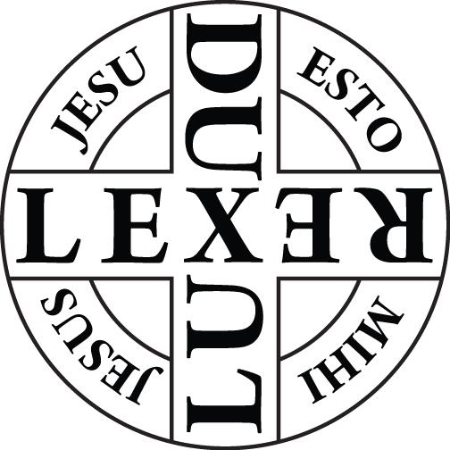
PRAYER CLOTHS
I love being part of a global community of Christians dedicated to the ministry of healing, which is The International Order of St Luke the Physician (OSL). Over the years it has encouraged; challenged; taught and empowered me to minister in this vital part of Christian ministry and outreach. We often use Prayer Cloths in our ministry and below is all the information you will need to incorporate them into your healing ministry.
This is a method that is particularly appropriate when the recipient is unable to be physically present for ministry. Prayer Cloths are a tangible reminder to the recipients of the reality of God’s love and of his presence in their need. We have sent them all over the world and seen God work powerfully through this ministry.
We emphasise that there is nothing ‘magical’ in the cloths themselves but that they are a point of contact with God, as well as being a reminder to the recipient of all that God can do, and of his love for them. Included with the cloth is a card explaining their origin and use and including a prayer for the individual recipient.
Their use originated in ACTS19:11-12
God did extraordinary miracles through Paul, ¹² so that even handkerchiefs and aprons that had touched him were taken to the sick, and their illnesses were cured, and the evil spirits left them.
According to Romans 12:3 we are all given, a measure of faith. Thus the prayer cloth can be a channel for the faith the recipient has in God’s love and power and for the healing they need.
The Bible has many examples of the different ways in which people approach God, common to these is the fact that each used a point of contact. e.g.
The woman with the issue of blood touched the hem of Jesus’ garment; Matt 9:20-22 She was afraid to approach him because she was deemed ritually unclean so touched the hem of his garment and for her this was a point of contact.
Jesus and his disciples laid hands on people to heal them;e.g. Matt 9: 27 -31 the two blind men; Matt 8:1-4, the man with leprosy; Mar 3:7-12, Jesus had healed many people so those with diseases were pushing forward to touch him; and many more.
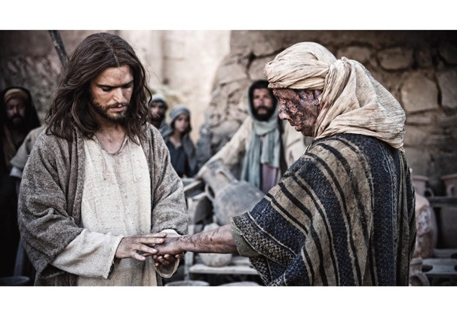Today, in the healing ministry we too often lay hands on people as we minister to them.
People who were sick wore aprons and handkerchiefs touched by Paul which their friends and neighbours brought to them; (see above) even Peter’s shadow on them became the point of contact.
In the Old Testament the staff of Moses was used to divine purpose; Exod 7:8-9; 14-19; 8:16-17; 10:13-14. He used it at God’s command to demonstrate God’s power to Pharoah and later to part the waters of the red sea.
The mantle of Elijah was used to part the waters; 2 Kings 2:8-9 and Elisha used it for the same purpose after Elijah was taken up to heaven.
The oil of anointing was used to consecrate altars and individuals; Leviticus 8:12; Moses poured some of the anointing oil on Aaron’s head and anointed him to consecrate him.
Psalm 45:7 You love righteousness and hate wickedness; therefore God, your God, has set you above your companions by anointing you with the oil of joy. Today oil of anointing is still used at baptism, consecration of those called to God’s service and for healing.

So Prayer Cloths are a very simple but effective form of healing ministry which can be practised by us all, including those who are no longer physically active and perhaps housebound, but still want to play their part in the ministry of healing. They could make and prepare Prayer Cloths for others to use.
The great thing about Prayer Cloths is their multiplicity of applications. A number of Prayer Cloths can be pre-prepared for general use, praying God will meet the eventual recipient at their point of need, bringing healing and peace. These can then be distributed as needed, see below for some ideas. Other Prayer Cloths can be blessed during healing ministry for the particular need that has been presented, and offered to the individuals concerned.
Here is a list of potential circumstances in which they could be used:
- For you to give to those for whom you pray eg at a Healing service.
- To carry with you to offer someone when God puts you into one of those situations where he is using you to be his hands, feet and mouth. I’m sure you have all had such occasions and found yourself offering prayer to an individual. The prayer cloth can be a tangible reminder for them of your prayer and God’s grace.
- With the permission of the relevant authorities, there are a number of places where Prayer Cloths could be left. The most obvious is hospitals, most hospitals have chaplains and they would be the first point of contact. I would especially love to see Prayer Cloths available in intensive care units; neo natal wards; geriatric wards but they would be a blessing on any ward where they could be offered to Christians or those who want to believe.
Clearly with all the regulations in place today, staff cannot simply hand them out, but it soon becomes obvious if a patient has a faith, and then a cloth could be offered.
- Prayer Cloths could also be left with ambulance stations for crews to take out with them. Often, as they chat with the patient, it will become apparent to the crew that the patient is a Christian. If this is so, a prayer cloth can be offered;
- The police often find themselves in a situation where they are offering comfort to the injured, sick or frightened and again the opportunity for offering a Prayer Cloth might arise.
- Prayer Cloths are particularly appreciated in residential homes and hospices. As people approach the end of life, they can become frightened, and a Prayer Cloth can bring great comfort.
- You could also keep a supply in your church and take them with you when going on prayer walks or to any outreach event so that you have them to offer to strangers if it seems appropriate.
- You could also offer them to the children and young people who attend your church as a symbol of your prayers for them; for example as they move school; prepare for exams or leave for university etc.
- If you have access to a Christian school, you could make them for the pupils as a sign that you are praying for them.
In the wake of the Covid epidemic we are all a bit more aware of the potential for infection, but simple precautions can be taken to ensure the Prayer Cloths are safe to pass on. The most obvious is to seal them into the envelope and then leave them for at least 72 hours before posting or giving them to the recipient. Using hand gel and wearing masks while making them would also be an added protection.

Making a Prayer Cloth
You will need:
- white handkerchiefs, (cheapest from your local market stalls or online; even cheaper if you make them yourself from squares of white sheeting. Cutting the squares out with pinking shears avoids the need to hem them.)
- Fabric pens;
- a piece of plastic or card, (plastic file pockets will do the job)
- oil of healing (ask your minister for some);
- a card with a simple message; your church’s contact details and the scripture verse Acts 19:11-12 (see example below)
- an envelope
Fold the handkerchief into quarters then open it out flat. Lay the handkerchief flat on the table. Slip a piece of plastic/card under one quarter (or if using a single sheet of fabric place the plastic or card beneath this) and draw a cross in the centre. Next trace over the cross, using the healing oil provided, and as you do so pray together for the person for whom it is intended. You may like to use a prayer of blessing, focusing on their particular need or a more generic prayer, see below. That’s all there is to it.

The Lord Bless you as you hold this Prayer Cloth. May he meet you at your point of need; may you receive his healing and peace; may you be assured of his unending love for you. Amen

The Revd Christine Low. The International Order of St Luke the Physician (UK)

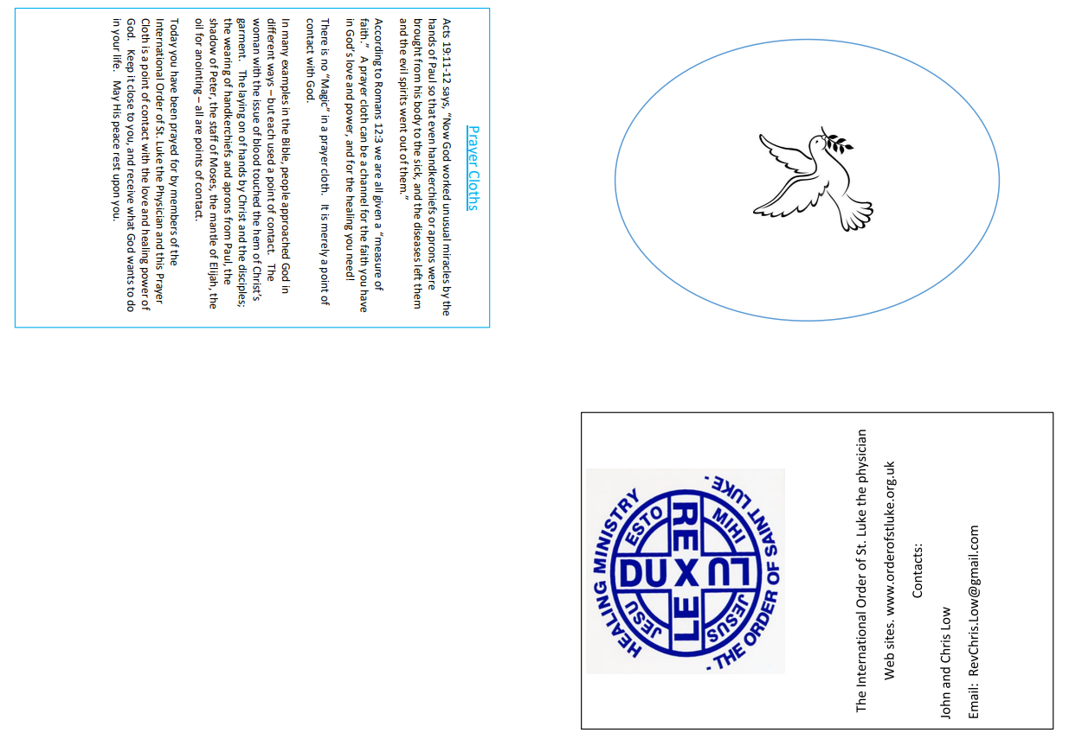
The Revd Christine Low. The International Order of St Luke the Physician (UK)

