Guide on ‘How to – claim Gift Aid’
Date: 27th July 2022

Disclaimer
Please note that this guide, ‘How to - claim Gift Aid’, is not exhaustive. The guide was sourced from HMRC and Parish Resources websites.
The guide is current on the 27th July 2022. The guide will be checked regularly to ensure that any changes to HMRC policy, regarding Gift Aid, will be reflected in the guide.
I have provided links to specific areas on the HMRC and Parish Resource websites where relevant.
I have attached relevant donor record and schedule templates and examples of completed templates to the guide for use and reference.
If you have any queries please contact Janet Daye at the Diocese of Sheffield. Contact details are at the bottom of this page.

Janet Daye
Treasurer and Church Operations Project Support Officer | The Diocese of Sheffield
Tel: 07731998063
Web: www.sheffield.anglican.org | Post: 95-99 Effingham Street, Rotherham, S65 1BL

Follow us on Twitter @DioceseofSheff
Find us on https://www.facebook.com/dioceseofsheffield

The Sheffield Diocesan Board of Finance is a company limited by guarantee and registered in England (No 196087) at Diocesan Church House, 95-99 Effingham Street, Rotherham S65 1BL. Registered Charity No. 245861
Contents Page
What is Gift Aid 3
To make a Gift Aid claim you must: 3
- Register with HMRC 3
- Have a Gift Aid Declaration for eligible donations 3
- Consider topping up your Gift Aid claim under the Gift Aid Small Donations Scheme (GASDS) 6
- Follow special rules for claiming Gift Aid 7
- Keep A Donation Record for all Gift Aid claims 7
- Know how to claim Gift Aid 9
- Submit your Gift Aid claim 11
Other useful information to know
- Frequency of gift aid claims 14
- When you must claim 14
- Keeping records 14
- When you’ll get paid 15
- For help on your claim
- Advice on church collections for 3rd party charities 15
- Tax relief for higher earners 15

What is Gift Aid
You can claim back from HMRC 25p every time an individual donates £1. This is called Gift Aid.
To make a Gift Aid claim:
- Register with HMRC
Separate instruction sheets are available on how to register for Gift Aid. Please see the attached document ‘How to – Register with HMRC to claim gift aid’. Use this set of instructions first and then follow the rest of the registration process on the Parish Resources website. The link is:
Claiming-Online-December-2019.pdf (churchofengland.org)

- Have a Gift Aid Declaration for eligible donations
When a donor completes a gift aid declaration it gives the church permission to claim Gift Aid on donations given by:
- Planned Giving received by standing order, cheque
- One-off Donations received by cheque, online bank transfers
- Cash or cheques given through the Envelope Scheme
To claim GA on cash donations by individuals (not GASDS), cash must be put in individual envelopes with customer details and a completed gift aid declaration, if a declaration has not already been provided.
- Website giving
Website donations legally require an online Gift Aid Declaration. Paper versions are needed in some situations and a tick box alongside contact details. The process for a gift aid declaration varies depending on the website’s 3rd party back-end software.
- Contactless giving
Only if the donation station has a built-in gift aid declaration and allows the donor to complete the declaration for contactless donations greater than £30.
2.1. Gift Aid cannot be claimed on the following:
- Payroll giving
- Limited Companies
- Goods or services
- Shares
- Vouchers or charity cards
- Membership fees

2.2. What a gift aid declaration must include:

There is no set design for a declaration form or a verbal declaration, but it must include:
- the name of your charity
- the donor’s full name
- the donor’s home address
- whether the declaration covers past, present, or future donations or just a single donation
- a statement that the donor wants Gift Aid to apply (this could be a tick box on a written or online declaration)
- an explanation that the donor needs to pay the same amount or more of UK Income Tax and/or Capital Gains Tax as all charities and CASCs will claim on the donor’s gifts in a tax year and that the donor is responsible to pay any difference.
A declaration by a donor can be made in writing, verbally, or online. Whichever format you use, donors must provide the required information for your Gift Aid claim to be valid.
A verbal declaration must be recorded or confirmed in writing.
It’s important that you keep all Gift Aid declarations. A Gift Aid declaration must be available for any claim made on a donor’s donation.
2.3. Changes to a donor’s circumstances
It is the responsibility of the person who completed the declaration to inform you of any changes to their name, address, or tax status in writing. A letter, email, or text message is acceptable. A copy of the instruction from the donor must be kept with their gift aid declaration. Any future claims regarding this donor must reflect the changes that were notified, from the date of the instruction.
2.4. Sponsored Events and Gift Aid declaration
If you’re organising a sponsored event, like a marathon, your sponsorship forms can include a Gift Aid declaration. The forms must also include the:
- amount of donations collected
- date that pledged donations were collected
- date, when the sums collected, were handed over to you
Explain to the donor that they need to pay the same amount or more of UK Income Tax and/or Capital Gains Tax as all charities and CASCs will claim on the donor’s gifts in a tax year and that the donor is responsible to pay any difference.

2.5. Rules around sponsorship of a fundraising event
- Gift Aid declaration must be completed by all sponsors
- If the event is to be held abroad then flights, accommodation, and other support costs are not gift-aidable
- Deposits or registration fees are not eligible
- If the sponsor is connected to the event participant then their donation is only gift-aidable if the participant pays the full support costs to take part in the event.
2.6. Here are links to Gift Aid Declaration templates that you can use for your church:
for multiple donations:
https://assets.publishing.service.gov.uk/government/uploads/system/uploads/attachment_data/file/468016/Charity_GAD_Multiple_Donations.pdf
for one-off declarations:
https://assets.publishing.service.gov.uk/government/uploads/system/uploads/attachment_data/file/467898/Charity_GAD_Single_Donation.pdf
for sponsored events:
https://assets.publishing.service.gov.uk/government/uploads/system/uploads/attachment_data/file/473639/Sponsorship_and_Gift_Aid_declaration_form_-_Nov_2015.pdf

- Consider topping up your Gift Aid claim under the Gift Aid Small Donations Scheme (GASDS)
Before you make a claim for Gift Aid it is worth considering claiming for a top-up payment on small cash or contactless donations of £30 or less under the Gift Aid Small Donations Scheme at the same time.
You do not need to know the identity of the donors or collect Gift Aid declarations.
3.1. Donations are acceptable under GASDS if:
- Received by contactless terminal by card, phone, or another device
- The cash is in any currency
- The donation is made in the UK
- Donations are deposited in a UK bank account
- There are no benefit links to the donor on receipt of the donation
- Cash donations are for either food or drink
3.2. To claim top-up payments for donations you must:
- have claimed Gift Aid in the same tax year as you want to claim a top-up payment
- not have incurred a penalty on a Gift Aid or GASDS claim in the current or previous tax year
3.3. You cannot claim GASDS for:
- donations that come with a valid Gift Aid declaration
- membership fees
- a £30 portion of a larger gift
3.4. What is the maximum amount of small donations and top-up payments you can make in a year:
It is the lower of:
- £8,000
- 10 times the amount you receive in Gift Aid donations - this is known as the matching rule
For example, if you receive £100 in Gift Aid donations, you can claim top-up payments on £1,000 worth of small donations under the matching rule. This works out as £250 in top-up payments.
To satisfy the matching rule, you must make claims on Gift Aid and small donations in the same tax year that you receive them.
If your charity has a community building eg a church hall you may be able to claim on more donations than the £8,000 limit
For further advice on claiming on donations raised at community buildings or connected charities please refer to HMRC guidance:
Claim top-up payments for the Gift Aid Small Donations Scheme - GOV.UK (www.gov.uk)

Follow special rules for claiming Gift Aid
There are special rules for:
- selling goods on behalf of individuals, for example through a charity shop
- charity events or to view charity property
- charity auctions
- volunteer expenses donated back to your charity
- funds raised through charities involved in running schools

- Keep a Donation’s Record for all Gift Aid claims
5.1. For donations that have a valid gift aid declaration
A spreadsheet is most often used to record all regular and one-off donations given by donors. You should use a separate spreadsheet for each claim period. This information will provide the necessary supporting evidence required in order for a church to make a gift aid claim. Ensure the following is recorded:
- Donor name
- regular monthly payment amounts and irregular payment amounts per month
The record should be filed together with the claim.
Attached is a spreadsheet template for recording donations and an example of a completed one.
The example and template automatically sum the donations recorded for each donor in the end column. It is the total figures for each donor you use when claiming Gift Aid.
The forms will automatically sum the total amount donated per month. The total amount is in the last row underneath the listing of all the donors.
5.2. For cash collections eligible under GASDS
You need to keep records of small donations as evidence of your claim. Two people should ideally check and count the cash collected.
You should record:
- how much money was collected, including each denomination of coins and notes
- the date the money was collected
- that no individual donation was greater than £30
- name and signature of the people who counted the cash.

5.3. For contactless donations
If you’ve collected contactless donations you’ll need to keep the records produced by the contactless terminal.
If you can, add gift aid declarations to your donation station. This will capture any donations that are greater than £30 and then you can claim gift aid on the full donated amount.

5.4. Retaining donation records
A donation record must be kept 6 years from end of financial year in which the donations were made. Eg a record was made of donations given during 2019, and a claim was made in 2020. The record must be retained until 31st December 2025

6. Know how to claim Gift Aid
You can claim Gift Aid using Charities Online with:
- eligible software, like a database
- a spreadsheet of your donations
For claims of over 1,000 donations you must use software.
To apply by post use form ChR1, which you can get from the charities helpline.the
HMRC has a list of eligible software and service suppliers listed on their website. All the suppliers have provided evidence that they have developed software that can interact with the HMRC Charities Online service. You can find the list here:
https://www.gov.uk/government/publications/charities-online-commercial-software-suppliers/charities-online-commercial-software-suppliers
The list includes:
- accounting software that enables you to claim Gift Aid directly: eg ExpensePlus and Liberty Accounts
- donations management software that enables you to claim Gift Aid directly: eg Data Developments – Donations Co-Ordinator.

6.1. Completion of the HMRC’s schedules to enable an online claim
HMRC require the schedule spreadsheets to be submitted in Open Document format (ODF). This means that you will need to have either of the software programs below installed on your computer:
• Microsoft Excel - Microsoft Office 2010 for Microsoft Windows
• LibreOffice 3.5 for Microsoft Windows, Apple Mac OS and Linux
I have attached a Microsoft Office 2010 schedule template for your use- ODS schedule template.

The Libre Office software and its associated schedule can be accessed from the link below.
Schedule spreadsheet to claim back tax on Gift Aid donations - GOV.UK (www.gov.uk)

6.1.1. Instructions on how to complete the schedule for Microsoft Office
At the top of the ODF schedule template there are instructions for completing the spreadsheet. Underneath the schedule instructions there is a link to Charities Online if you require further guidance.
After the schedule instructions there are examples on how to complete the schedule.
Underneath the example section are two boxes on the left-hand side. You will need to enter the earliest donation date for your claim in Box 1, and any overclaimed tax amounts from previous claims in Box 2.
Below that you need to enter information about the donors:
- enter their Title, Initial or First Name and Last name
- enter house name or number and the Postcode
- for the donor enter the date of the donation, or the last donation date if the donor has given multiple donations within the period you are claiming for.
- the total amount the donor has given.
You can enter aggregated donations of £20 or less, up to a total of £1,000 per row. This can be helpful for one-off Gift Aid envelopes, or for one-off donations where the donor has completed a gift aid declaration.
To claim aggregated donations, leave the donor details blank, and enter a simple description in the Aggregated Donations box.
The spreadsheet will calculate the total amount of donations at the top of the schedule.
Save and close the spreadsheet. The file must be saved as an ODS file.
6.2. GASDS - Claiming Gift Aid on donations received from other church buildings in your parish
If donations are given at the church hall or donations have been given at another church in your parish you will need to complete the community building schedule. The schedule that you will need to complete for community buildings is attached.
You’ll need to enter in the schedule spreadsheet the:
- community building name (maximum 160 characters)
- first line of the building address (maximum 40 characters)
- postcode
If you don’t know the postcode, you can find it out from the Royal Mail postcode finder website. If the building doesn’t have a postcode, enter the postcode of the nearest building.
You’ll also need to enter the:
- end of the tax year date for which you’re claiming under GASDS
- the amount of all small donations of £20 or less collected in each community building

7. Submit your Gift Aid claim
7.1. Log into the Government Gateway
Follow the link: Claim Gift Aid online - GOV.UK (www.gov.uk)
Click the Green ‘Start Now’ button and it will you directly to the Government Gateway.
Enter your ID and password and click the green ‘Sign In’ button.
Access the services available.
Select ‘View Account’ – highlighted in the red box in the screen shot below

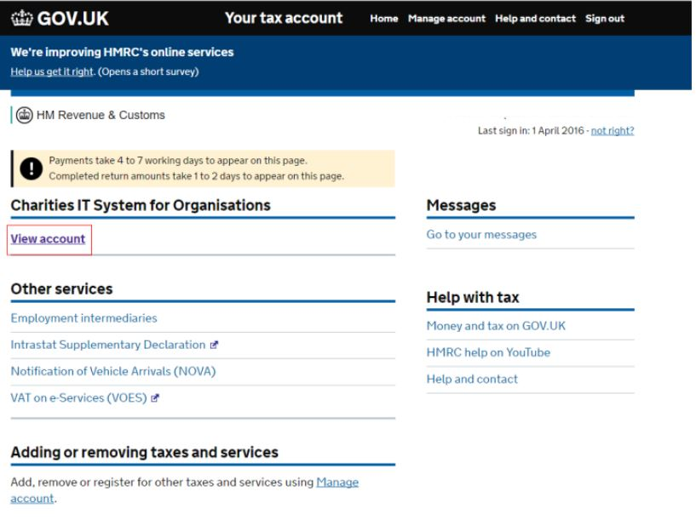
Click on ‘Make a charity repayment claim’.
This will take you to another window. This window will ask you questions about your claim.

7.2. Answer questions about your claim
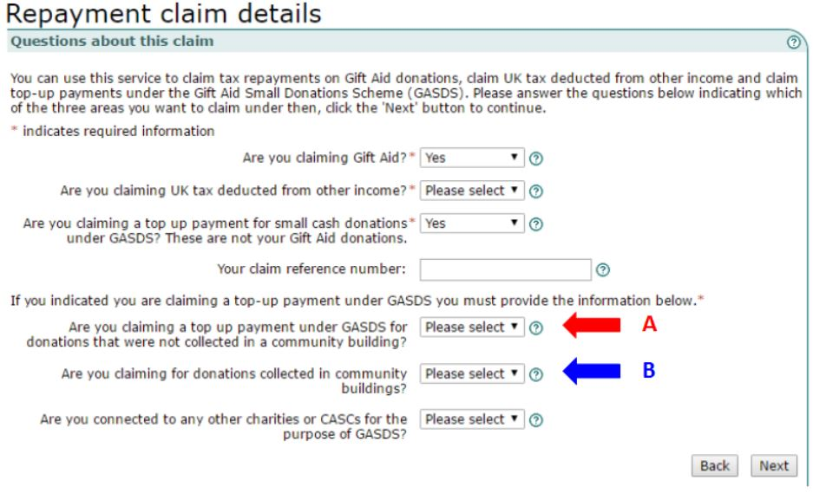For the questions shown in the window select:
- Are you claiming gift aid? - Yes
- Are you claiming UK tax deducted from other income? – No.
- Are you claiming a top up payment for small cash donations under GASDS? These are not your gift aid donations. – Select Yes if claiming for GASDS otherwise select No.
- If you have selected Yes to the question above and you have only one church building, you need to answer Yes for the question marked with the red A arrow otherwise answer No.
- If you raised collected cash in more than one building select Yes for the question marked with the blue B arrow.
- For the last question ‘Are you connected to any other charities or CASCS for the purpose of GASDS’ select the question mark icon at the end of the drop-down box which will give you help on which answer to select. Usually the answer is No.
- In the box labelled ‘Your claim reference number’ enter a name that identifies the claim and claim period.
Select the ‘Next’ button
Another window will appear that asks you for details about your church.

7.3. Enter details about your church
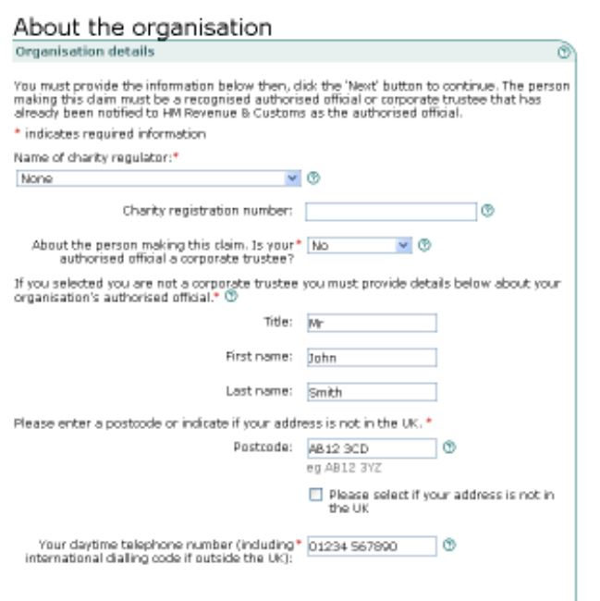

Provide the following information in the window:
- If you are not registered with the Charity Commission enter ‘None’ from the drop-down menu under the title ‘Name of Charity Regulator’.
- Leave the field for Charity registration number blank.
- Select ‘No’ for the question ‘Is your authorised official a corporate trustee?’
- Provide details of your authorised official in the next set of fields. The official is the person authorised to claim on your behalf. You would have notified HMRC of your chosen authoriser when you registered for gift aid or if you made a change to the authorised user.

7.4. Upload your completed schedules
Once the details of your organisation have been entered you will be asked to upload your completed schedules in this order:
- Gift Aid Schedule
- And/or Community Buildings schedule.
The schedules are automatically checked to see if there are any formatting errors. The system will show your uploaded schedule and show it incorporated on the screen if everything is okay. You will be told if there is an error in the schedule. At this point you will need to correct the schedule and re upload it.
When you are happy that the correct schedules have been uploaded, the system will tell you whether the schedule has been successfully attached.
After you have successfully attached your schedules you will be asked to enter your GASDS total amount If you selected ‘Yes’ to the question ‘Are you claiming a top up payment under GASDS for donations not collected in a community building’.
7.5. The final stage is to submit your claim
To submit, you will first have to tick the check box on the Declaration screen. Then, you will need to re-enter your user ID and password as a security check. Once this information is entered select the ‘Submit’ button. On successful submission you will be given a submission receipt reference number. Please print this screen or make a note of the reference number you have been given.

8. Frequency of gift aid claims
You can make as many claims as you wish throughout the financial year. It is best to claim on a regular basis as this will help with cash flow. If a church receives large amounts of donations per month it is also advisable to claim on a regular basis. Most claims are made on either a three, six monthly or annual basis.
9. When you must claim
You need to claim for a donation within 4 years of the end of the church financial year (31st December) you received it in.
You must claim on cash donations under the Gift Aid Small Donations Scheme within 2 years of the end of the financial year that the donations were collected in.

10. Keeping records
You need to keep records of these donations for a further two years as stated in point 9 above.

11. When you’ll get paid
You’ll get a Gift Aid payment by BACS within:
- 4 weeks if you claimed online
- 5 weeks if you claimed by post using form ChR1
12. For help on your claim
Contact the charities helpline if your repayment is wrong or if you submitted an incorrect claim.
13. Advice on Church Collections
You cannot claim Gift Aid on donations collected in your church that are for another charity. This is because the money collected is not part of the church’s income.
If a church chooses to set up a fund to raise money for a charity, then the money collected forms part of the church’s income. In this case, the church (which is a charity in its own right) can claim any Gift Aid due.
14. Tax relief for higher earners
It is advisable to make it clear on any publicity material or newsletters that higher earners can obtain tax relief on any gift-aided donations they make.
If a higher rate tax payer gives a donation they can obtain relief for their donation on their tax return, increasing their basic rate band by the gross charitable donation for the year. This boosts the proportion of their income taxed at the lower rate. You can find more details and how to claim tax relief here: https://www.gov.uk/donating-to-charity/gift-aid

