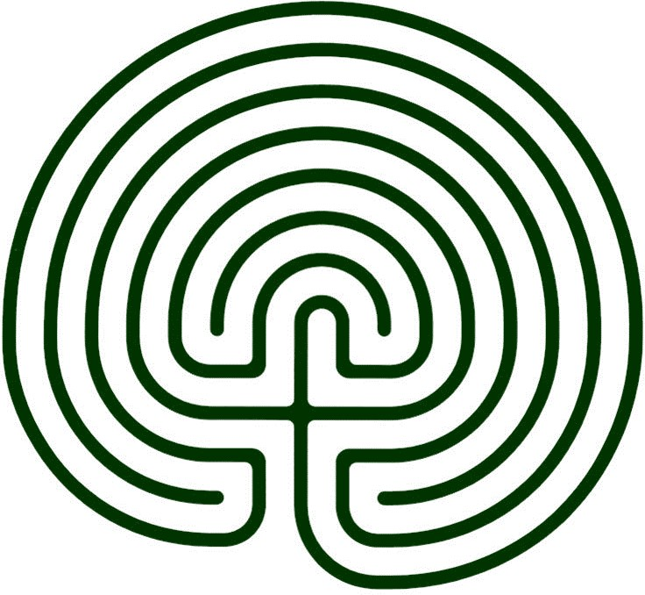
Praying with a

Finger Labyrinth

